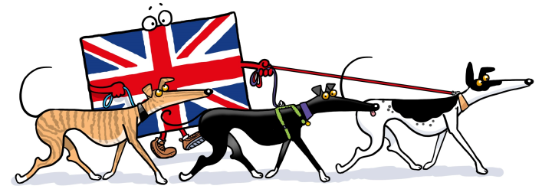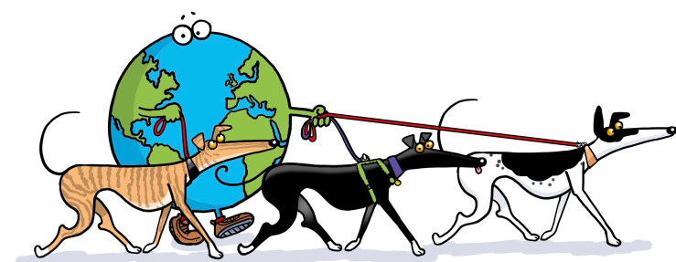
THE GREAT GLOBAL GREYHOUND WALK
Coming To A Location Near You

MEDIA INFORMATION as at (insert date)

WALKING ALL OVER THE WORLD

Sunday 19th June is a very special day for greyhounds, lurchers and their owners who will all be stepping out to celebrate the 7th, but newly renamed, Great Global Greyhound Walk. Hounds and humans will be walking simultaneously at parks, woods, beaches, heaths and at the odd Stately Home right across the world. Numerous walks have already been confirmed is places as far afield as Canada and New Zealand as well as London, Beddgelert in Wales, Edinburgh, Cornwall and Yorkshire. More locations are being added day by day and we hope to have a walk taking place in as many countries as possible.

(Enter organiser’s name here) welcomes all sight hound owners in the (location) area to join the walk which commences at (enter time) and the meeting point is (enter address and postcode)

(Enter organiser’s name here) said “This is the **th time I have arranged a walk and we are delighted to be part of this global event. We are hoping for a huge turnout of local greyhounds, lurchers and any other sighthounds. The idea of the walk is to celebrate particularly retired racing greyhounds, to raise awareness and promote them as wonderful family pets once their racing days are over. Greyhound make great companions, they love human company, are gentle, docile and affectionate and walk really well on the lead. Contrary to popular belief, greyhounds don’t require much exercise – just two 20 minute walks a day and although they enjoy longer walks too, they are equally happy relaxing on a comfy sofa”.
In 2015, the previously named Great British Greyhound Walk, had 4605 dogs attending walks all over the world and the success of these walks prompted our new name, the Great Global Greyhound Walk. Can we reach the magic 5000 sighthounds this year? – we hope so. So please join us. There is no need to book but if you need any further information, please call me on (phone number). You can also join our on-line community via Facebook where there are competitions and prizes and our website, www.greatglobalgreyhoundwalk.co.uk will be offering some fantastic merchandising.

ENDS

ADDITIONAL INFORMATION

The Great Global Greyhound Walk is organised by Greyhound Walks, Registered Charity no 1127875. The charity aims to socialise greyhounds and lurchers; promote and raise awareness of retired greyhounds as family pets through voluntary contributions and events; raise money for needy Essex, Suffolk and Hertfordshire greyhounds, support Essex, Suffolk and Hertfordshire rehoming kennels and animal rescues who rehome greyhounds.

For more information, please visit: www.greyhoundwalks.co.uk or www.greatglobalgreyhoundwalk.co.uk

For an interview with your local organiser, please contact: (insert name and phone number)

For an interview with the Press Officer, please call Eve Regelous on 07947 796783 or email gggwpress@gmail.com

