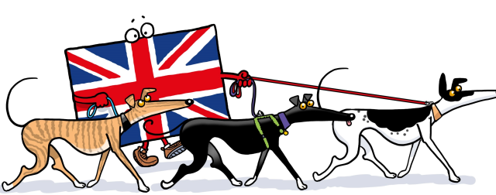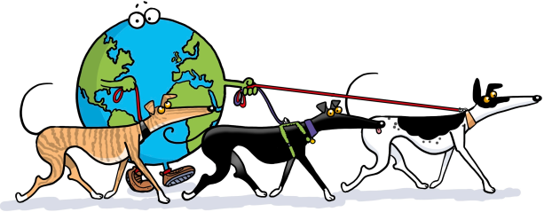
THE GREAT GLOBAL GREYHOUND WALK
Coming To A Location Near You

PROMOTING A WALK OFFLINE (IN THE REAL WORLD)
Sending out a press release is a good way to let local media know that a Walk is happening in your area. If you haven’t dealt with the media before it can feel a bit daunting but don’t be deterred, it is easy if you follow the guide notes below
Fill out the pre-written press release in preparation and print a copy out so that can refer to it when you make a call. Also make some notes about key things you want to put across.
Then get on the phone and ring the papers. You will find the numbers online, the telephone directory or Yell.com.
Ask:
- Who is responsible for local news items or covering events? Get the name and ask to be put through to them. If they are not available, ask for an email address or get the full postal address.
- If you do manage to speak to someone, tell them about the Walk, the aims of the GGGW and how much the coverage would mean to the owners and the greyhounds. Be enthusiastic and upbeat and keep to your notes. If they are interested, they will ask you the questions. Ask if you can send them your press pack.
- A press pack includes the following: The main press release, a copy of the 2016 GGGW Logo (either GB or Global), If possible, a photo/pdf of a long shot walk, a photo/pdf of a group walk – preferably one from your local area. (If you are stuck with any of these, email gggwpress@gmail.com and our Press Officer will send you the appropriate photos). If you want to send out further press releases on the run up to the walk, please contact the press officer (details below)
- Ask for a copy deadline date and email/send the information a few days before.
- Ask if anyone would be free to attend the event or perhaps send a photographer? You can never guarantee it but always ring and check a week before hand to see if they have someone they can spare.
- Do remember to say thank you for their time and appreciate their support (even if they haven’t given it)
- A follow-up call to ensure the contact has received the info is not a bad idea either
Of course, you could just send the press release and it might be covered but nothing works better than personal contact.

Continued……….

NEW THIS YEAR:
If you would like a personalised press release specific to your area, our Press Officer is happy to write you one. Please email gggwpress@gmail.com and include a phone number so that further details can be supplied.

Web: www.greatglobalgreyhoundwalk.co.uk
Press Officer: Eve Regelous
Email: gggwpress@gmail.com
Telephone: 07947 796783

