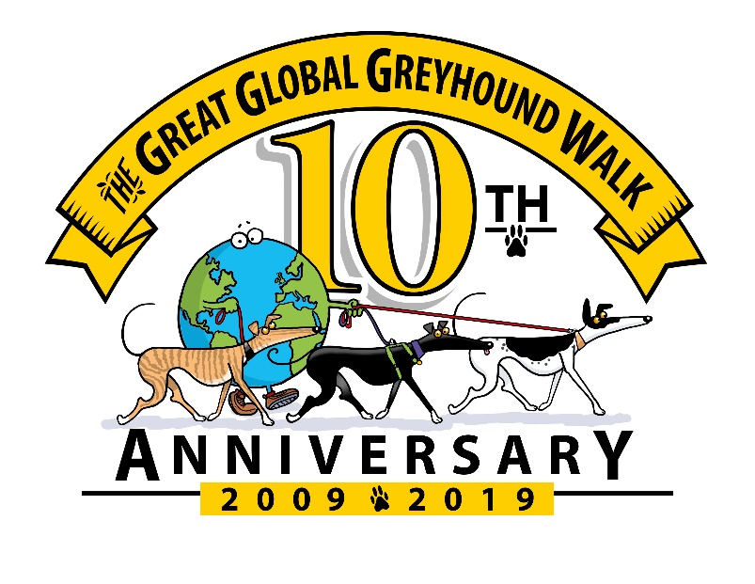
GREAT GLOBAL GREYHOUND WALK 2019
PRESS RELEASE (Enter date here)
The Great Global Greyhound Walk, which takes place on Sunday 9th June 2019, is an annual celebration of one of the most historic and recognisable breeds of dog, famed for their incredible athleticism, noble stature, gentle nature, and calm temperament.
The event is the brainchild of Greyhound Walks, a registered charity which began in East Anglia, with the aim of socialising and promoting greyhounds as pets by organising local walks. Ten years ago their small group of volunteers decided to bring together sighthound owners across the UK with a national event, originally known as the “Great British Greyhound Walk”. The event captured the hearts and minds of greyhound owners across the UK and in 2014 the walk became global, with last year’s event seeing walks as far afield as New Zealand, USA, throughout Europe, and even Abu Dhabi.
All walks are organised by local volunteers and (Enter organiser’s name here) welcomes all sight hound owners in the (location) area to join their walk which commences at (enter time) and the meeting point is (enter address and postcode)
(Enter organiser's name here) said “This is the **th time I have arranged a walk for GGGW and am delighted to be part of this global event. We are hoping for a big turnout of local greyhounds, lurchers and all other sighthounds. The idea of the walk is to celebrate greyhounds, to raise awareness and promote them as wonderful pets once their racing days are over. Greyhounds make great companions, they love human company, walk nicely on the lead and contrary to popular belief, greyhounds don't require much exercise – just two 20minute walks a day, although many can enjoy much more too. They really are 40 mph couch potatoes!
2019 is the 10th anniversary of this wonderful event and GGGW aims to have its most successful walk yet – in numbers of walks, participants, money raised for greyhound rehoming charities and finding forever homes for kennel dogs.
Further details can be found on the website – www.greatglobalgreyhoundwalk.co.uk
The Great Global Greyhound Walk is an annual dog walking event that brings together greyhounds and other sighthounds, with their owners to raise awareness of the breed and show the public what wonderful pets they make. The GGGW is organised by Greyhound Walks – Registered Charity No. 1127875. The charity aims to socialise greyhounds and lurchers; promote awareness of retired greyhounds as family pets; through voluntary contributions and events raise money for needy greyhounds.
Please note all our admin team and walk organisers are volunteers.

