August 2021 Great Global Greyhound Walk Press Release

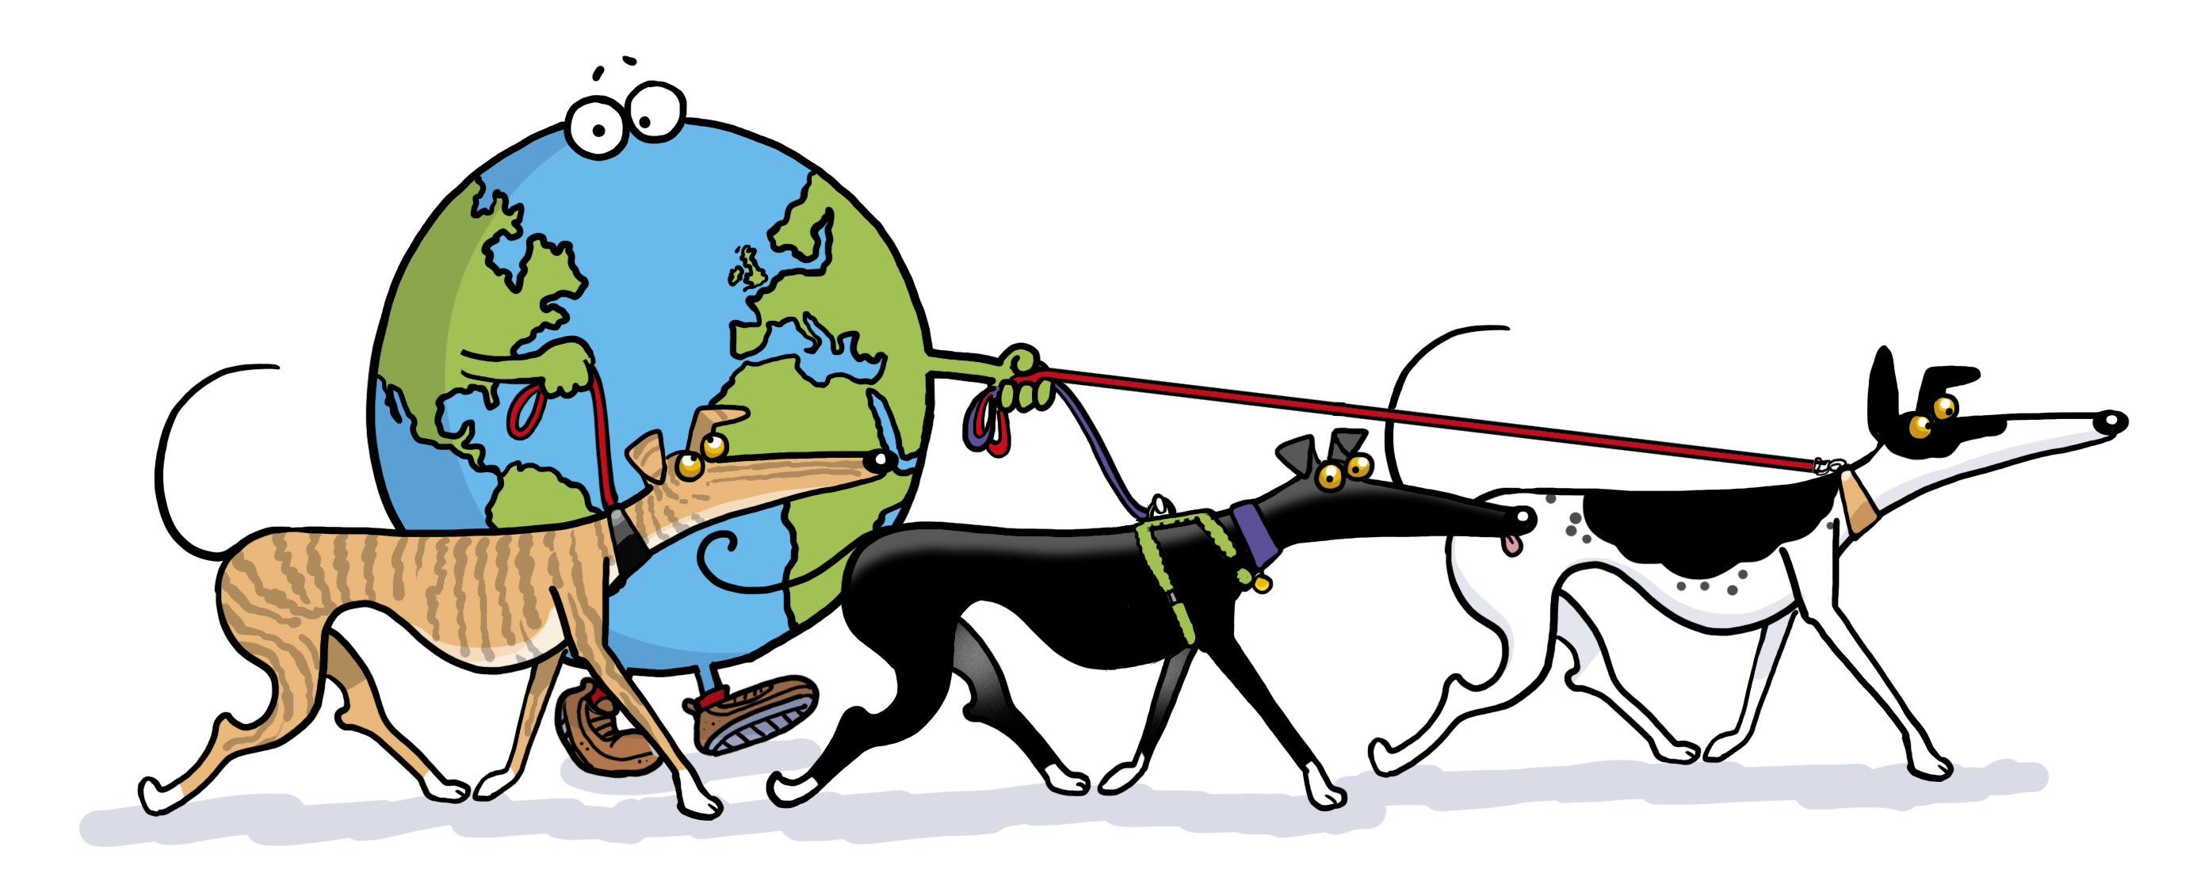
BIG, BOLD & BLUE!

The Great Global Greyhound Walk (GGGW) aims to build on its increasing success and go big, bold and blue in 2021!
Nearly 8,800 sighthounds walked 'together' across the globe in 2019 and with the cancellation of the 2020 event due to covid, the aim is now for 10,000 hounds!
The theme for the event on Sunday 19th September is the colour blue and people and hounds are encouraged to dress up whilst participating in the 100's of walks organised across the world, with the aim to promote greyhounds, and their sighthound cousins, as fantastic pets.

Despite the world battling against Coronavirus there has been an amazing initial response to the 2021 running, which has been delayed from its usual date in June to allow for covid regulations to become more manageable in many countries. Within 48 hours of opening the website for registrations, there were over 50 walk listings submitted.

Originally named the Great British Greyhound Walk this annual event was begun by the charity Greyhound Walks. Founded by one lady, Janet Peacock, who wanted some company to walk with her greyhound, the charity organises walks primarily across East Anglia to unite sighthounds and their owners – giving both the chance to relax and socialise together. The idea of a national (and now very much international!) annual walk was sown and has grown to be a very popular date in greyhound lovers diaries.

Greyhounds are misunderstood by many – believed to be high maintenance and needing lots of exercise; nothing could be further from the truth – they are known as 40mph couch potatoes for good reason! Instantly recognisable with their sleek noble look, greyhounds have calm temperaments and gentle natures. Most are happy with just 2 twenty minute walks per day – but many are happy to do more too. They are more adaptable than people realise and can suit many different lifestyles and family circumstances – some even living with small furry animals.

Over the 10 years its been running, the GGGW has expanded immensely in both numbers and spread of walks, with registrations across the UK from Scotland to Jersey, and globally involving participants in North America, mainland Europe and Australasia, to name a few. Indeed 2021, will see the first ever GGGW registered in Africa, taking place in Cape Town! Some previous walks have attracted over 200 hounds – quite a sight! - however it is important to note that small walks involving just 2 or 3 hounds are equally important to the overall figures and helps increase the coverage across the globe that the event can reach. With covid regulations still tight in many countries there is also the option of registering a private walk, so people can walk alone safely and still be a part of this global event.

The ultimate goal is for the general public to see the hounds out on their walk, meet them, and learn about their lovely characteristics - and maybe even give one a home in the future. In the past, the GGGW has been proven to find forever homes for hounds that needed them – it is the hope that this side of the event will also increase.

Registrations for walks are now open and can be made via the website, where you can also find more information - www.greatglobalgreyhoundwalk.co.uk

The Great Global Greyhound Walk is organised by Greyhound Walks – Registered Charity No. 1127875.
The charity aims to socialise greyhounds and lurchers; promote awareness of retired greyhounds as family pets; through voluntary contributions and events raise money for needy Essex, Suffolk & Hertfordshire greyhounds; support Essex, Suffolk & Hertfordshire rehoming kennels and animal rescues who rehome greyhounds.

Please note all our admin team and walk organisers are volunteers

