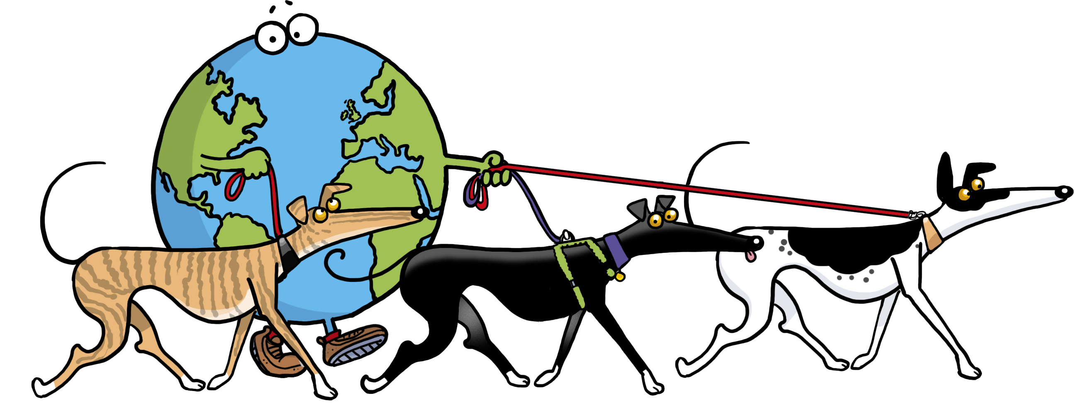
Walk Risk Assessment

Health & Safety Risk Assessment:
Venue:
Name: |  | Signature:
Job Title: Walk Organiser |  | Date:
Persons Affected:
Category | None | Qty Under 10 | Qty Over 10
Volunteers
Participants
Public

Risk Evaluation
Chance of incident |  | Severity of injury
 |  | Slight 1 | Serious 2 | Major 3
1 Very unlikely |  | 1 | 2 | 3
2 Possible |  | 2 | 4 | 6
3 Likely |  | 3 | 6 | 9
1 | Acceptable |  | Unlikely to cause injury, risk to health or property damage
2 | Acceptable |  | Unlikely to cause injury, risk to health or property damage
3 | Acceptable but |  | Possible risk of injury risk to health or property damage. Control measures must be in place
4 | Unacceptable |  | Supervision control measures written records must be in place. Try to reduce the risk further or abandoning event
6 | Unacceptable |  | Revisit procedures/assessment to reduce the risk to the lowest acceptable evaluation possible. Event not to go ahead at this level
9 | Unacceptable |  | Abandon event immediately

Risk evaluation score. Enter N/A if risk not present or applicable
Type of Incident | Score | Precautionary Measures
Slips/trips/falls |  | Recce in advance, avoid areas of concern, advise participants of possible hazards. Risk minimised
Restricted access |  | Walk to keep public areas at all times Risk minimised
Dog waste |  | All participants advised to clear up and dispose responsibly. Risk minimised
Dog bite |  | Dogs to be muzzled if required, new dogs to have muzzle available. Risk minimised
Deep water |  | All dogs on lead
Vehicle movements |  | Congregating in car park avoided. Risk Minimised
Weather |  | Be prepared for warm weather and ensure participants are made aware of caring for thier dog and walk is suitably paced. Risk minimised
Interaction with public |  | Make walkers aware of being considerate to others. Very important if venueis a busy public area if wather is fine. Not all members of the public are dog lovers so care to be taken not to overwhelm the park. Risk minimised

Significant risks identified above 4
None applicable
Existing control measures
Standard GGGW rules apply (outlined at pre walk talk)
Additional control measures
Standard pre-walk instuction to be given by walk co-ordinator (or nominated person). To include the GGGW rules regarding keeping dogs on lead, keeping to designated paths, muzzling nervous dogs and cleaning up after their dog.
Participants to be responsible for thier ( and their dog/s)welfare in and around car parks.
Walkers and/or their dogs not to enter restricted areas including but not restricted to childrens play areas, adjoining farmland, etc
COVID-19 additional measures:
List here any other measures needed to make sure event is run within local government guidelines regarding Coronavirus. Make sure all walk attendees are aware of such measures and that they are followed through.

I confirm that no significate risks exist and that all residual evaluations are acceptable (4 or below) provided that all the above control measures are implemented.
Sign | Yes | No

Additions or diversions of any of the above risk/s should be noted on the reverse of this Risk Assessment

